Department of History

FALL 2022 COURSE GUIDE
Department of History

history

.camden.rutgers.edu

Department of History

http://history.camden.rutgers.edu/
Please visit our website for more information about the department, including:

- Faculty specialties and areas of interest
- Faculty news and student accomplishments
- History major and minor requirements
- Advising
- History Graduate program

And much more!

Department of History
Faculty of Arts & Sciences Rutgers University
Camden 429 Cooper St.
Camden, NJ 08102
Phone: 856-225-6080
Fax: 856-225-6806

2
FACULTY
Nicole Belolan  Director  Continuing Education Program in Historic Preservation  Mid-Atlantic Regional Center for the Humanities  (MARCH)  nicole.belolan@rutgers.edu  (570) 441-91216 | Charlene Mires  Director of MARCH  (Mid-Atlantic Regional Center for the Humanities)  Professor of History charlene.mires@rutgers.edu  (856) 225-6069
Kendra Boyd  Assistant Professor of History kendra.boyd@rutgers.edu  (856) 225-2716 | Susan Mokhberi  Associate Professor of History  s.mokhberi@rutgers.edu  (856) 225-2712
Katherine Epstein  Associate Professor of History kce17@camden.rutgers.edu  (856) 225-2721  Undergraduate Program Coordinator | Andrew Shankman  Professor of History shankman@rutgers.edu  (856) 225-6477  Graduate Program Director
Evan Jewell  Assistant Professor of History ej281@rutgers.edu  (856) 225-2813  Co-Director, History Club  SABBATICAL | Lorrin Thomas  Associate Professor of History lthomas2@camden.rutgers.edu  (856) 225-2656
Nick Kapur  Associate Professor of History nick.kapur@rutgers.edu  (856) 225-2713  Co-Director, History Club | Wendy Woloson  Professor of History ww207@camden.rutgers.edu  (856) 225-2711  Department Chair  Director, Graduate and Undergraduate  Internships•
Emily Marker
Assistant Professor of History emily.marker@rutgers.edu
(856) 225-6075

To graduate with a major in History, students must complete 33 credits (or 11 x 3-credit courses) of History classes.

One of these courses must be the required core course for the major, Perspectives on History
(50:509:299), which History majors should take as soon as they can. Perspectives will teach history majors the following skills: 1. how to analyze primary sources; 2. how to read secondary sources in a critical manner; 3. how to cite sources properly; 4. how to write to the expectations of the discipline of History; 5. how to construct a historical argument; 6. how to evaluate the integrity, reliability, and usefulness of disparate sources; and 7. how to conduct independent research.

For the remaining 30 credits besides Perspectives, History majors must meet several requirements:
- 18 of these credits must be from courses taken at Rutgers
- 18 of these credits must be from 300- or 400- level courses
- A maximum of 12 credits may be from 100- and 200- level courses, but no more than 6 credits can be counted from Western Civilization I, II, and III (510:101, 510:102, 510:103) and Development of the United States I and II (512:201 and 512:202).
- At least 3 credits must be from each of the three geographical areas: 510 (European), 512 (the United States), and 516 (African, Asian, Latin American, and comparative history).
- No more than 9 credits will be accepted for the major from online courses, of which six credits may be at the 100-200 level, and 3 credits may be at the 300-400 level.
(This policy will not apply to students who declared the History major before fall 2016, and is waived for Spring, 2020-Spring, 2021.)
Grades lower than C do not count toward fulfillment of the History major requirement.

History internships and courses offered in the university’s Honors College may also count toward the major, with the department Chair’s permission.

If students wish, they may take more than 33 credits of History courses. Students who would like to immerse themselves in reading and research should consider finding a faculty member to supervise their Honor’s Thesis in History (509:495), to be conducted as an independent study in addition to the 33 credits demanded of the major.

Those students seeking certification in teaching should be aware that a requirement is to take a course from a selection dealing with human and intercultural relations. Several history courses may be counted for this purpose and for the History major.

Students should feel free to drop in and visit us in our offices at 429 Cooper Street. The History
Department Chair is Dr. Wendy Woloson, (856) 225-2711, the Undergraduate Program
Coordinator is Dr. Richard Demirjian, (856) 225-6744, and the History Graduate Director is Dr. Andrew
Shankman, (856) 225-6477. They will gladly answer questions about our classes, about majoring in History, and about transferring credit for History courses taken at other schools. Students are also welcome to consult with a faculty member of their choice for History advising.

4

History Concentrations
Optional History concentrations for both History majors and History minors

- Concentrations are available to all current and future majors/minors
- Choose any one of 16 thematic or geographic tracks (see lists below) as your concentration within the major
- Complete any 5 courses in any concentration by the time you graduate
- These 5 courses count toward your major or minor -- no extra courses required!
- Concentrations can be declared or changed at any time
- Concentrations can be put on resumes and job applications
- Concentrations more easily explain your main area of interest to parents, friends, or employers
- Concentrations are always optional -- you can still opt for no concentration and complete a general History major or minor

Available History Concentrations

(see pages 21 - 23 of this Course Guide for a list of Fall 2022 courses and the concentrations they fulfill)
Thematic Concentrations | Geographic Concentrations
Business, Finance, & Economics | China, Japan, & Asia
Culture, Literature, & Art | Africa & the Middle East
Empires, Imperialism, & Colonialism | Europe & Its Empires
Gender, Sexuality, & Society | Latin America & the Caribbean
International Relations & Global Affairs | United States
Law, Politics, & Government | Global
Public & Professional History
Race, Ethnicity, & Immigration
Science, Technology, & Medicine
Religion, Philosophy
World Cultures & Civilizations

HISTORY 101: WHAT IS HISTORY?
50:509:101:01
M/W 2:05 pm – 3:35 pm
Professor Thomas

Gen Ed: AAI (Art, Aesthetics and Theories of Interpretation)

Most people think they already know what history is: it’s whatever happened in the past—the names, dates, and events that fill textbooks and high school classes. But what actually happened in the past is not always clear. The past is the subject of intense conflicts—from “history wars” among academics and politicians to actual military confrontations between nations. History, then, is not about memorizing facts. It is about asking questions about the past, finding clues, and piecing those clues together into compelling stories. Telling these stories forces us to make choices about what to put in and what to leave out; about main plots and subplots; about lead and supporting characters; and about how to connect the dots with our imaginations when information is lacking.

Does this mean history is fiction? Who gets to decide history—whose stories should we listen to and accept as true? How are ideas and practices of history different in different parts of the world? How do political struggles, in the United States and around the globe, shape the way people see the past and use it in their everyday lives? Can history predict or improve the future, and if not, what is history for? Must histories only be written in books, or can myths, movies, music, art, or fairy tales fulfill a similar purpose? This course will introduce you to various ways in which scholars and societies in different global contexts have approached the past. But above all, it will teach you new ways of thinking critically about the world you live in—its past, present, and future.

In pondering these and other questions about the nature of history and the past, we will draw upon examples from American, European, and nonwestern history. We will develop our understanding of the actual practice of making history, including analyzing historical sources, and developing a historical narrative. We will ponder the fundamental nature of history at the intersections of science, art, and daily life.

PUBLIC HISTORY PRACTICE
50:509:300:01
By Arrangement Professor Mires

Get your hands on history: This is an individualized opportunity to gain knowledge of local and regional history while contributing to a public history project based at the Mid-Atlantic Regional Center for the Humanities (MARCH) at Rutgers-Camden. The options include historic house research and curatorship for the Cooper Street Historic District and research and digital publishing for The Encyclopedia of Greater Philadelphia. In addition to readings in local and regional history, students will be provided with training and ongoing supervision and feedback while working approximately six hours per week on-site on their selected projects (or remotely if the center is not open). This course is by arrangement, with permission of the instructor, and is open to juniors and seniors with a GPA of 3.0 and above.

UNDERGRADUATE INTERNSHIP
50:509:475:01
BY ARRANGEMENT
Professor Woloson
A supervised internship, usually unpaid, at a museum, historical society, archive, or library.

WESTERN CIVILIZATION III
50:510:103:01
M/W 12:30 pm – 1:50 pm
Professor Marker

GEN ED: HAC (Heritages and Civilizations), EXP (Experimental Learning)

This course explores the development of modern politics, society and culture in Europe and beyond from the mid-eighteenth century to the present. With such a vast time span under consideration, this course is not intended to be an exhaustive survey of modern European history. Rather, we will use a combination of lectures and primary texts as points of entry into the major historical events and trends of the era—the Enlightenment, the rise of capitalism, the French Revolution, industrialization, nationalism, imperialism, the World Wars, and decolonization. Coursework includes lecture, discussion, brief homework assignments, short papers, a mid-term and a final exam.
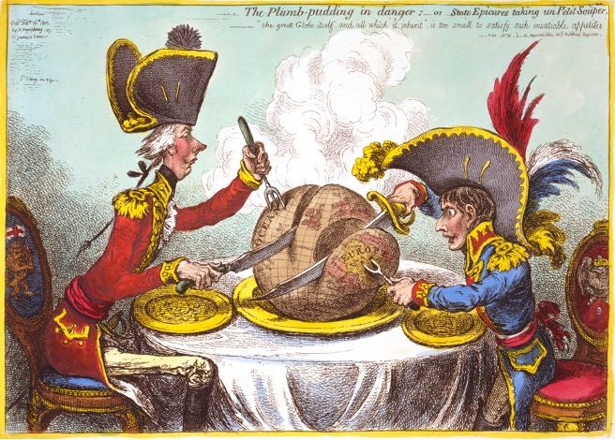

ANCIENT HISTORY ROME
50:510:204:01
M/W 3:45 pm – 5:05 pm
Instructor TBD
At the Battle of Actium in 31 BCE, Gaius Octavius (better known as Augustus, the first emperor) finally conquered the last of the Greeks—and the Romans as well. This course explores the rise of Rome and its empire in the provinces on either side of this watershed moment. From the emergence of Rome as a Mediterranean power in the late 200s BCE with the defeat of the Carthaginian empire, down to the early principate of the Roman emperors, students will study the major developments in Roman imperialism in this course. In addition to a chronological survey, students will discuss the impact of Roman rule on social, religious, economic and legal developments throughout Europe, Northern Africa, and the Near East, as well as interactions with regions beyond Roman control (e.g. India). Special consideration will be paid to how life differed for people in the empire according to their region and place (e.g. urban vs rural), local pre-Roman culture, social and legal status (e.g. slave, free or freed), religion, gender, racial difference and other factors. Students will engage closely with primary sources, such as art, architecture, archaeology and texts in translation, as well as some modern scholarship.
KINGS, QUEENS, AND ENLIGHTENED IDEAS
50:510:321:01
T/TH 11:10 am – 12:30 pm
Professor Mokhberi

GEN ED: HAC (Heritages and Civilizations)

This course provides a general overview of the dynamic changes in European ideas, politics, and culture during the 17th and 18th centuries. We will examine monarchies, such as France, Prussia, England, and Russia and the commercial and dynastic competitions that resulted in great wars. France under Louis XIV served as the model of strong kingship but critics of the French state abounded. Enlightenment intellectuals called Philosophes, challenged traditional institutions and called for reform, raising issues of religious tolerance and freedom from injustices that resonate today.
.

ENGLAND IN THE AGE OF SHAKESPEARE
50:510:351:01
T/TH 9:35 am – 10:55 am
Professor Shankman

GEN ED: GCM (Global Communities)
(Counts toward Legal Studies minor)
The period of English history that produced William Shakespeare has just about everything: The Wars of the Roses (the inspiration for Game of Thrones), Henry VIII and all six of his wives, Catholics killing Protestants and Protestants killing Catholics, Elizabeth the virgin queen, Shakespeare (of course), bishops clipping the ears off of ministers, the English people clipping off the head of their king, communists and naked Quakers, the first truly modern revolution in world history, and, oh yes, the origins of almost all of the ideas that would later shape American law and government and the political and economic ideas that shaped the early United States.
More specifically: this course will examine the years from the late 1400s to the mid-1700s to discover how tiny, insignificant, and peripheral England became the dominant global power between the late fifteenth century and the mid eighteenth century. Broadly, this period was the age of Shakespeare, when the English people lived all of the major themes and issues he wrote about: chaos and violence, the origins of democracy, and the consequences of respecting and neglecting duty, honor, responsibility, and faith. England in the Age of Shakespeare is the story of the origins of much of the modern world as we now experience it.

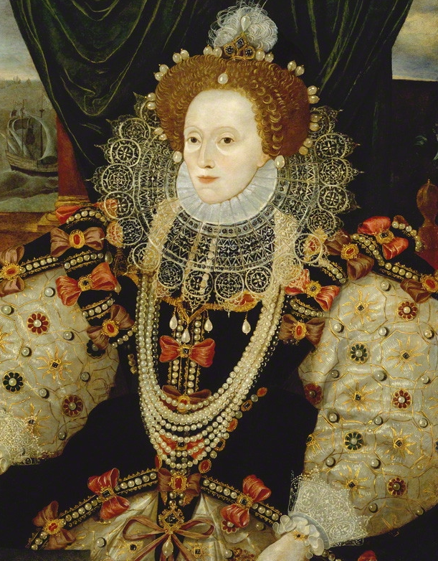
DEVELOPMENT OF US I
50:512:201:01
M/W 9:35 am – 10:55 am
Kim Martin

GEN ED: USW (United States in the World)
This course traces the path of American history from prior to European colonization, through the colonial period, Imperial Crisis, Revolution, Civil War, and Reconstruction. We will examine the most important political, economic, social, and cultural developments of the 17th-19th centuries, and observe how different groups of people shaped and were affected by such developments. Learning about the past involves a careful effort to understand the ideas and beliefs that motivated people to act in certain specific ways, within particular historical circumstances. Development of U.S. I is an introductory course, intended to acquaint students with various ideas, events and people from this particular segment of America’s past, and to introduce students to some of the questions and debates that animate the study of early American history.

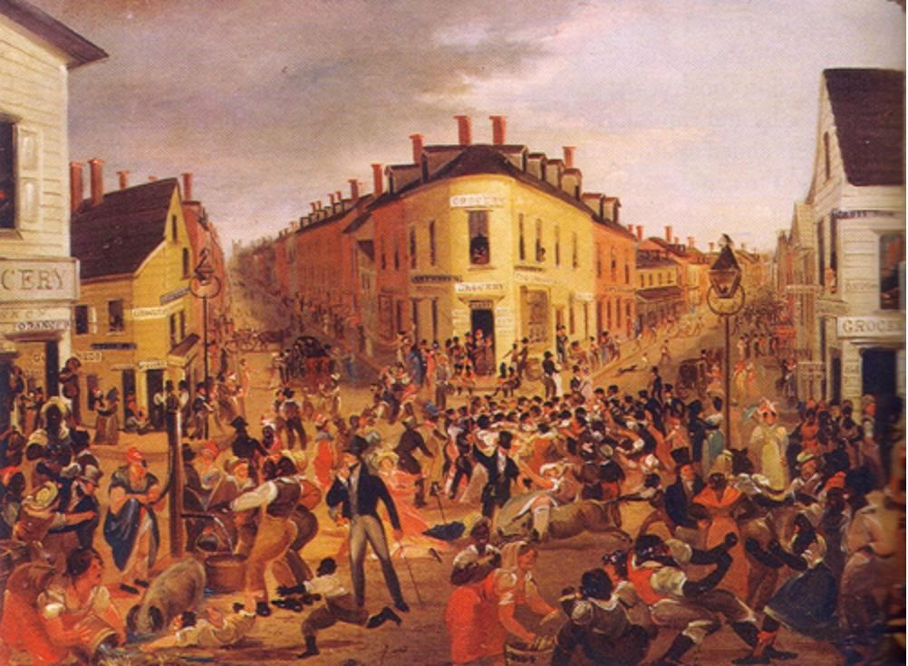

DEVELOPMENT OF UNITED STATES II
50:512:202:01
T/TH 11:10 am – 12:30 pm
Instructor: TBD
This course examines the political, economic, social, and military history of the United States from the 1860s through the 1970s. The course will also examine the roles played by ethnicity, race, gender, class, the development of a national market economy, and the emergence of a powerful national state in shaping ideas about American identity and its place in the world.
AFRICAN-AMERICAN HISTORY I
50:512:203:01
T/TH 2:00 pm – 3:20 pm
Professor Boyd
GEN ED: DIV (Multicultural Diversity in the US), USW (US in the World)
This course provides an introduction to the history of African Americans, surveying African origins, the history of slavery, black resistance and rebellion, and the evolution of black leadership through the Civil War (ending in 1865). Focal points include the Atlantic slave trade, the transition from African to African American culture, the impact of slavery on gender roles and the black family, the rise of the abolitionist movement, self-emancipation, and African Americans' role in the Civil War. We will explore the major political developments of the era, as well as how slavery and the Civil War were memorialized.

RACE, ETHNICITY, AND MIGRATION
50:512:280:01
M/W 12:30 pm – 1:50 pm
Professor Thomas
The U.S. has long defined itself as a “nation of immigrants.” How did that description develop and change over time, and what has it come to mean by the 21st century? During the first half of this course, we will look at how racial and ethnic groups have been historically constructed over the 19th and 20th centuries in the United States. We will analyze a variety of ideas about race and ethnicity – including “foreignness,” “whiteness,” “blackness,” and various forms of “otherness” – and discuss how those ideas have changed as a result of shifting economic, political, and social contexts.
During the second half of the course, we will focus on debates over immigration, migration, race, and ethnicity in the last 50 years. Students will collaborate on compiling reliable resources and historical analysis of these issues in order to assess what is at stake and how historical perspective can help us navigate these conflicts.

UNITED STATES IN THE GILDED
AGE AND PROGRESSIVE ERA
50:512:325:01
T/TH 2:00 pm – 3:20 pm
Professor Epstein
Massive inequality. Racial divisions. Empire. The United States of today looks a lot like the United States between the Civil War to World War I, the period when modern US history really began. If you want to understand the forces that still shape Americans’ debates over income distribution, racism and sexism, and the country’s place in the world, you need to understand the Gilded Age and the Progressive Era.

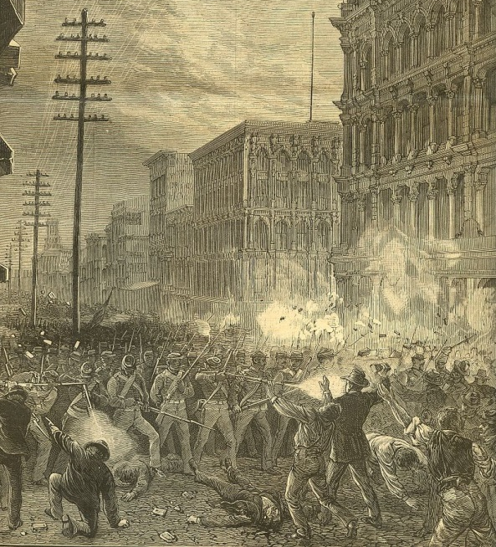
National Guard troops
firing on demonstrators, 1877
This class will provide students with a better informed perspective on today’s world, a firmer understanding of US history during a pivotal period, and a foundation for more advanced study. It will focus on the following events and themes: Reconstruction; the emergence of industrial capitalism; the labor movement; Populism; changes in the armed forces; the establishment of Jim Crow; gender relations; the transformation of the United States from a continental to a global power; Progressivism; and the experience of world war. As much as possible, students will learn about this period from the people who lived through it—ex-slaves, industrialists, farmers, factory workers, immigrants, presidents, Native Americans, Supreme Court justices, suffragettes, and others. In so doing, they will improve their ability to evaluate information, to write, and to think critically about issues of great historical and contemporary importance.

CIVIL RIGHTS MOVEMENTS
50:512:340:01
T /TH 11:10 am – 12:30 pm
Professor Boyd
This course provides an intensive examination of the civil rights movement. We will take a long view of the movement, beginning with early civil rights activism in the 1940s, though the course will mostly focuses on the period 1954-1968. Students will explore well-known and lesser-known protests and campaigns, including the pivotal case of Brown v. Board of Education in 1954; the Montgomery Bus Boycott of 1955-1956; the Greensboro lunch counter sit-ins of 1960; the Freedom Rides of 1961; the Birmingham campaign of 1963; the March on Washington of 1963; the Civil Rights Act of 1964; the Mississippi Freedom Summer of 1964; and the Voting Rights Act of 1965. The course will also examine how the Civil Rights Movement intersected with the Black Power, anti-war, feminist, and gay liberation movements.

COMMAND HISTORY
50:512:365:01
T/TH 3:35 pm – 4:55 pm
Professor Epstein
Students who have taken Command History in the past generally regard it as difficult, rewarding—and hard to describe. Taught seminar-style (rather than lecture-style), the course seeks to probe the similarities and differences between military command and the study of history. This may sound like a weird analogy, but it serves as a springboard for us to think through, as a class, some of the cognitive challenges and ethical dilemmas that characterize both activities, as well as (on a smaller scale) everyday life. Like commanders, historians hold lives in their hands, and they can be responsible for the death of people’s reputations much as commanders can be responsible for people’s physical deaths. Thus military command and the study of history both involve power, responsibility, and the infliction of violence. Who lives, who dies, and why—on the battlefield and in the book? To answer these questions, we will read a mixture of texts from the disciplines of history (mainly military history), philosophy, religious studies, and literature.
The course is meant to be useful, in the sense of giving students new ways to think about what they encounter in their daily lives. Overwhelmed by conflicting partisan takes on the news of the day? You’re not so different from military commanders or historians, who have to make decisions about life and death—physical and reputational—in the face of uncertain, excessive, and inconsistent information. Not sure how to meet all the demands on your time and energy from people you want to do right by? Again, welcome to being a commander or historian, who try to achieve some level of moral decency when moral perfection is impossible. This is hard stuff, but a liberal arts education is about equipping yourself to tackle hard stuff, and this course aims to help you do so.

Gangs of New York: Crime and Vice,
Law and Order in the 19th-Century City
50:512:380:01
M/W 2:05 pm -3:25 pm
(Counts toward Legal Studies minor)
Professor Woloson
This course explores the intersections of crime and vice, law and order in 19th-century urban America. We will cover topics including the changes in law enforcement and imprisonment over time; the intersections of crime, poverty, and emerging industrialization; the development of organized policing; social reform movements; and the origins of the modern carceral state.
We will read the stories of gamblers, prostitutes, pickpockets, thieves, conmen, and corrupt politicians, while considering the various social, political, economic, and cultural factors that encouraged their criminal activities. In addition, we will examine various responses by the state to control the urban underworld, including enacting legislation, establishing police forces, and launching reform efforts. Students will be asked to examine various primary and secondary sources, actively engage in class discussion, and write both short and long responses to the questions raised.

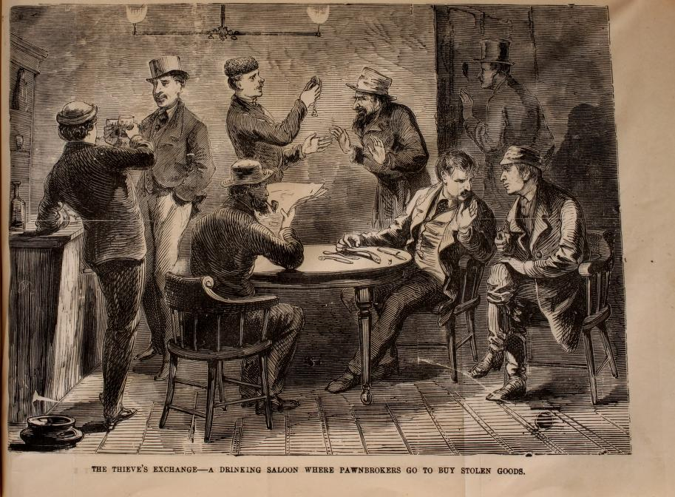
“The Thieve’s Exchange,” from the book Secrets of the Great City, by James McCabe (1868).

ISSUES IN PUBLIC HISTORY
50:512:381:01
T 6:00 pm – 8:50 pm
Professor Mires

Controversies over historical monuments are raising awareness of the issues embedded in the processes of creating, communicating, and contesting public understanding of history. This seminar goes behind the scenes of public history settings such as museums, historic sites, and archives to delve into these dynamics. Through a series of case studies, we will discover how historical narratives are constructed and communicated within history-focused organizations, in public spaces, and the digital realm. Students will expand professional networks by contributing to the annual Public History Year in Review (https://phyearbook.wordpress.com/);
collaborate on a study of the job market for public history; and deepen their understanding of the field with a seminar paper connecting public history scholarship with professional practice. Students from all fields are welcome in this seminar

GRADUATE

COURSES

READINGS IN 1945 TO PRESENT
56:512:508:01
W 6:00 pm – 8:50 pm
Professor Kapur
This course will investigate recent scholarship on the major developments in US and world history from the end of World War II up to the present day. In addition to considering the civil rights movement, the global revolution of the 1960s, the rise of feminism and environmentalism, and the conservative backlash, we will also consider the effects of globalization and financialization, the rise of multi-national corporations and NGOs, the triumph of neoliberalism, and the ongoing emergence of post-neoliberal world “populism.”

RESEARCH IN U.S., 1820 TO 1898
56:512:505:01
W 6:00 pm – 8:50 pm
Professor Shankman
Directed Research course for students who have taken any of the following courses: History 504: Readings to 1763, History 505: Readings 1763-1820, or History 506: Readings 1820-1898.

ISSUES IN PUBLIC HISTORY
56:512:531:01
T 6:00 pm – 8:50 pm
Professor Mires
Controversies over historical monuments are raising awareness of the issues embedded in the processes of creating, communicating, and contesting public understanding of history. This seminar goes behind the scenes of public history settings such as museums, historic sites, and archives to delve into these dynamics. Through a series of case studies, we will discover how historical narratives are constructed and communicated within history-focused organizations, in public spaces, and the digital realm. Students will expand professional networks by contributing to the annual Public History Year in Review (https://phyearbook.wordpress.com/); collaborate on a study of the job market for public history; and deepen their understanding of the field with a seminar paper connecting public history scholarship with professional practice. Students from all fields are welcome in this seminar.

READING IN GLOBAL HISTORY I
56:512:534:01
T 2:00 pm -5:00 pm
Professor Mokhberi
Globalization has emerged as the alternative to cultural and social theories of history but what precisely is global history? How is it different from a national history? Is it a “better” approach or does it come with its own set of pitfalls? This course will introduce students to writing world history. Students will discuss approaches and problems. We will analyze the work of historians who focus on conflict, difference, and incommensurability between cultures and those who find cooperation and connections across the globe. The class will contrast microhistories with macrohistories as approaches to studying the global. We will explore specific examples that focus on the movement of peoples, commodities, and diplomatic exchanges. Finally, we will discuss how global history can help us uncover the histories of networks, groups, diasporas, and marginalized groups who are often left out of national histories.
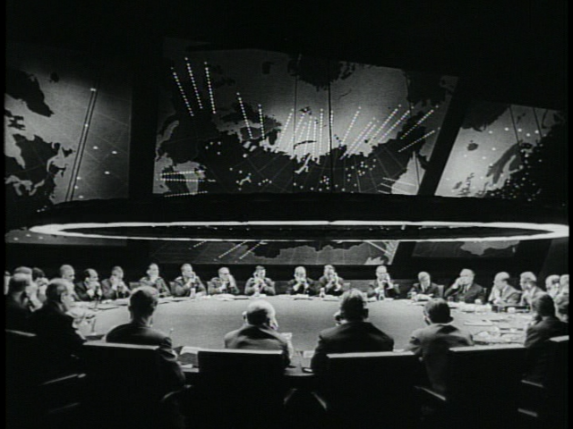
“Stanley Kubrick’s War Room”

THE CRAFT OF HISTORY
56:512:550:01
M 6:00 pm – 8:50 pm
Professor Marker
The Craft of History is unique in the Master’s program at Rutgers-Camden. Rather than a readings or research course in a particular area of history, this course is designed to familiarize students with major problems, questions, and methods that shape the discipline of history as a whole. In the first part of the course, we will explore how scholars have historicized the study of history itself. We’ll then consider a wide variety of competing methodological approaches to the study of the past and work through the major “historiographical turns” of the past few decades. The course will conclude with an examination of a few key historical debates, the boundaries between scholarship and fraud, and the politics of history-writing today.

HISTORY PRACTICUM
56:512:587:01
By Arrangement
Professor Mires
In collaboration with an on-campus center engaged in public humanities, each student will devise and carry out a project that builds knowledge and skills needed for independent historical consulting. This is an individualized experience, by arrangement. Students who intend to enroll should contact Professor Mires or other appropriate faculty advisor to begin a discussion of project proposals.

INTERNSHIP IN PUBLIC HISTORY
56:512:699:01
By Arrangement
Professor Woloson
Supervised work experience in a public history institution, involving hands-on projects over one semester or a summer.

Course Information Thematic Geographic
PUBLIC HISTORY PRACTICE  50:509:300:01  BY ARRANGEMENT  Professor Mires | Public & Professional History  Culture, Literature, & Art | United States History
WESTERN CIVILIZATION III  50:510:101:01  Professor Marker | Business, Finance, & Economics  Culture, Literature, & Art  Empires, Imperialism, & Colonialism  Gender, Sexuality, & Society  International Relations and Global Affairs  Law, Politics, & Government  Religion, Philosophy, & Ideas  Science, Technology, & Medicine  World Cultures & Civilizations | Africa & Middle East  Europe & Its Empires  Global History
ANCIENT HISTORY ROME  50:510:204:01  Professor Jewell | Culture, Literature, & Art  Empires, Imperialism, & Colonialism  Law, Politics, & Government  World Cultures & Civilizations | Europe & Its Empires
KINGS, QUEENS, AND ENLIGHTENED IDEAS  50:510:321:01  Professor Mokhberi | Culture, Literature, & Art  Empires, Imperialism, & Colonialism  Gender, Sexuality, & Society  International Relations and Global Affairs  Law, Politics, & Government  Religion, Philosophy, & Ideas  Science, Technology, & Medicine | Europe & Its Empires  Global History
ENGLAND IN THE AGE OF SHAKESPEARE  50:510:351:01  Professor Shankman | Business, Finance, & Economics  Gender, Sexuality, & Society  Law, Politics, & Government  Religion, Philosophy, & Ideas  World Cultures & Civilizations | Europe & Its Empires
DEVELOPMENT OF THE UNITED  STATES I  50:512:201:01  Kim Martin | Business, Finance, & Economics  Empires, Imperialism, & Colonialism  International Relations & Global Affairs  Law, Politics, & Government  Public & Professional History  Race, Ethnicity, & Immigration  Religion, Philosophy & Ideas  War, Peace & Diplomacy | United States History Global History
DEVELOPMENT OF THE UNITED  STATES II  50:512:202:01  Instructor: TBD | Business, Finance, & Economics  Empires, Imperialism, & Colonialism  International Relations & Global Affairs  Law, Politics, & Government  Public & Professional History  Race, Ethnicity, & Immigration  Religion, Philosophy & Ideas  War, Peace & Diplomacy | Latin America & the  Caribbean  United States History  Global History
AFRICAN-AMERICAN HISTORY I  50:512:203:01  Professor Boyd | Business, Finance, & Economics  Culture, Literature, & Art  Law, Politics, & Government  Public & Professional History  Race, Ethnicity, & Immigration  Religion, Philosophy & Ideas  World Cultures & Civilizations | United States History  Race, Ethnicity, and Immigration
RACE, ETHNICITY, MIGRATION  50:512:280:01  Professor Thomas | Law, Politics, & Government  Race, Ethnicity, & Immigration  Empire, Imperialism, & Colonialism | United States History  Latin America & the  Caribbean
US IN THE GILDED AGES AND  50:512:325:01  Professor Epstein | Business, Finance, & Economics  Law, Politics, & Government  Public & Professional History  Race, Ethnicity, & Immigration  Science, Technology, & Medicine  War, Peace, & Diplomacy | United States History
CIVIL RIGHTS MOVEMENT  50:512:340:01  Professor Boyd | Business, Finance, & Economics  Culture, Literature, & Art  Law, Politics, & Government  Public & Professional History  Race, Ethnicity, & Immigration  Religion, Philosophy & Ideas  World Cultures & Civilizations | United States History  Law, Politics, and Government  Race, Ethnicity, and Immigration
COMMAND HISTORY  50:512:365:01  Professor Epstein | War, Peace, & Diplomacy  Religion, Philosophy, and Ideas  Law, Politics, and Government | Europe & Its Empire  United States History
Gangs of New York: Crime and Vice, Law and Order in the 19th-Century CitY  50:512:380:01  M/W 2:05 pm -3:25 pm  (Counts toward Legal Studies minor)  Professor Woloson | Law, Politics, & Government | United States History
ISSUES IN PUBLIC HISTORY  50:512:381:01  Professor Mires | Gender, Sexuality, & Society  International Relations and Global Affairs  Law, Politics, & Government  Public & Professional History  Science, Technology, & Medicine  War, Peace, & Diplomacy | United States History
LATIN AMERICA I  56:516:211:01  (Instructor TBD) | Business, Finance, & Economics  Culture, Literature, & Art  Empire, Imperialism, & Colonialism  International Relations and Global Affairs  Law, Politics, & Government  Race, Ethnicity, & Immigration  Religion, Philosophy, & Ideas  War, Peace, & Diplomacy | Latin America & the  Caribbean  Global History
LEARNING COMMUNITIES: SAMURAI JAPAN  50:516:233:01  Professor Kapur | Business, Finance, & Economics; Culture,  Literature, & Art; Gender, Sexuality, &  Society; Law, Politics, & Government;  Religion, Philosophy, & Ideas; War, Peace,  & Diplomacy; World Cultures & Civilization | China, Japan, & Asia

 |  | Undergraduate Courses
Course Number | Course Index | Course Name |  |  | Time | Instructor
50:509:101:01 | 03925 | History 101: What is History? |  |  | M/W 2:05 pm – 3:25 pm | Professor Thomas
50:509:300:01 | 03926 | Public History Practice |  |  | By Arrangement | Professor Mires
50:509:475:01 | 03927 | Intern Public History |  |  | By Arrangement | Professor Woloson
50:510:103:01 | 18780 | Western Civilization III |  |  | M/W 12:30 pm – 1:50 pm | Professor Marker
50:510:204:01 | 03929 | Ancient History Rome |  |  | M/W 3:45 pm -5:05 pm | TBD
50:510:321:01 | 03930 | Kings, Queens, and Enlightened Ideas |  |  | T/TH 11:10 am – 12:30 pm | Professor Mokhberi
50:512:201:01 | 03933 | Development of US I |  |  | M/W 9:35 am -10:55 am | Kim Martin
50:512:202:01 | 03934 | Development of US II |  |  | T/TH 9:35 am – 10:55 am | TBD
50:512:203:01 | 03509 | African-American History I |  |  | T/TH 2:00 pm – 3:20 pm | Professor Boyd
50:512:280:01 | 03935 | Race, Ethnicity, & Migration |  |  | M/W 12:30 pm – 1:50 pm | Professor Thomas
50:512:325:01 | 03937 | US in the Gilded Age and Progressive ERA |  |  | T/TH 2:00 pm – 3:20 pm | Professor Epstein
50:512:340:01 | 03519 | Civil Rights Movement |  |  | T/TH 11:10 am – 12:30 pm | Professor Boyd
50:512:365:01 | 03938 | Command History |  |  | T/TH 3:35 pm – 4:55 pm | Professor Epstein
50:512:380:01 | 03786 | ST: Gangs of New York: Crime and Vice, Law and Order in the 19th Century City |  |  | M/W 2:05 pm – 3:25 pm | Professor Woloson
50:512:381:01 | 03939 | Issues in Public History |  |  | T 6:00 pm – 8:50 pm | Professor Mires
 |  | Graduate Courses
56:512:508:01 | 05097 |  | Readings in US, 1945 to Present | W 6:00 pm – 8:50 pm |  | Professor Kapur
56:512:510:01 | 05098 |  | Readings in US, 1820 to 1898 | TH 6:00 pm – 8:50 pm |  | Professor Shankman
56:512:531:01 | 03940 |  | Issues in Public History | T 6:00 pm – 8:50 pm |  | Professor Mires
56:512:534:01 | 05099 |  | Reading in Global History I | T 2:00 pm – 5:00 pm |  | Professor Mokhberi
56:512:550:01 | 05100 |  | The Craft of History | M 6:00 pm – 8:50 pm |  | Professor Marker
56:512:587:01 | 05101 |  | History Practicum | By Arrangement |  | Professor Mires
56:512:699:01 | 05105 |  | Internship in Public History | By Arrangement |  | Professor Woloson
24

