[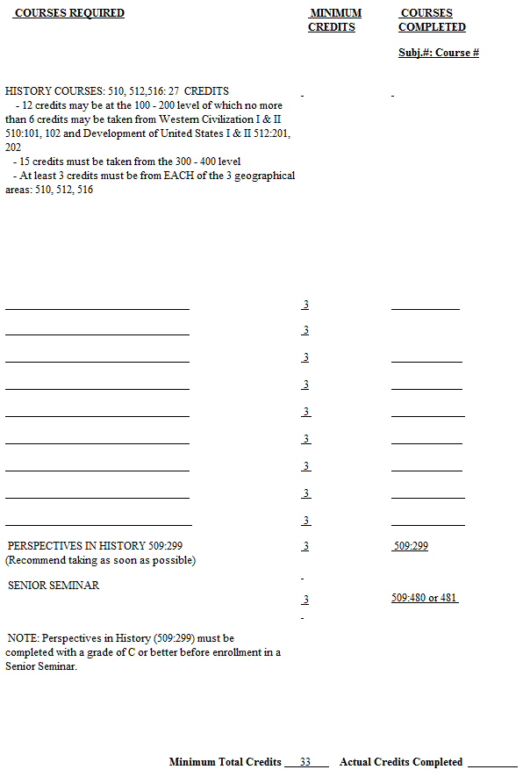](http://history.camden.rutgers.edu/files/2012/07/history-major-form.jpg)